**The Future of Food in the Antarctic: a report prepared for the British Antarctic Survey investigating the carbon intensity of food supplied to an Antarctic research station**



Prepared by

**Edmund Dickens**

**Table of Contents**

**Summary…………………………………………………………………………………………………………………………………………….3**

1. Introduction 4

2. Contextual setting 5

3. Research methods 7

4. Results 8

4.1. Frozen food 8

4.1.1. Beef, Lamb and Pork 8

4.1.2. Poultry 8

4.1.3. Dairy products 9

4.1.4. Fish & seafood 9

4.1.5. Other animal source foods 9

4.1.6. Potato products 10

4.1.7. Vegetables 10

4.1.8. Mycoprotein 10

4.2. Dry food 11

4.2.1. Milk and cream 11

4.2.2. Flour 11

4.2.3. Tinned vegetables 11

4.2.4. Beverages 13

4.2.5. Wine 13

4.2.6. Cooking oil 14

4.3. Fresh food 14

4.4. Transport 17

4.5. Storage 18

4.6. Cooking 20

4.7. Waste 22

4.8. Summary 22

5. Recommendations 23

6. Interviews – challenges and opportunities for implementation 24

7. Other issues and further research 26

8. Conclusions 28

9. Reference list 30

**Summary**

This report investigates the relationship between greenhouse gas emissions and the food supplied to Rothera research station. It is set in the context of the British Antarctic Survey (BAS) seeking to reduce its emissions in line with a 2040 net zero target, and wider concerns about climate change and environmental issues often associated with food systems.

The work centres around a piece of original research conducted as part of an MSc project to determine the above relationship, which uses a life-cycle assessment methodology to analyse food sent to Rothera in 2020 from the production stage through transport, storage, cooking and waste to gain a cradle-to-grave picture of food-related emissions. This analysis is preceded by information outlining the context in which the work has been undertaken and a description of the methods used. It is followed by a series of recommendations for reducing food-related emissions and improving the BAS food system more generally, supported by interviews with experienced BAS staff, before looking at areas for future research and some other related issues.

The key conclusions are as follows:

* Most of the emissions (about 60%) come from the production stage of the food, which varies significantly depending on the type of food (red meat has the highest, poultry and fish are in the middle, plant-based foods have the lowest emissions)
* The second highest emissions come from storing the food, primarily energy use from keeping food frozen in static reefers (shipping containers) at Rothera. This accounts for about 25%, followed by transport at 9%
* Dry and frozen food sent to Rothera in 2020 generated an estimated 263919kg CO2e over its life cycle, equivalent to about 1.25% of total BAS emissions that year
* Six recommendations are made to reduce the climate impact of the food supply chain and improve catering efficiency. These include decarbonising the food order by placing an emphasis on less carbon intensive food types, auditing suppliers and their own suppliers, improving the recording of environmental statistics to enable easier monitoring of progress, creating a named environmental champion for food, reviewing pre-deployment training on food issues and conducting further research in some specified areas
* Whilst some measures have been taken/are already planned to improve the sustainability of the food system, there are several easy wins remaining that could substantially reduce food-related emissions, especially important as many other BAS activities are carbon-intensive and hard to decarbonise (such as shipping)
* Taking the recommended steps is likely to produce co-benefits alongside emissions reductions, such as a healthier workforce, improved efficiencies (and reduced costs) and better quality and choice in Antarctic canteens
* In a year where food issues have made headlines several times, BAS has the chance to get out ahead and provide leadership on these issues both among the Antarctic research community and other organisations of a similar size

# Introduction

This report details the outcomes of a project run in the summer of 2021 that attempts to determine the global warming potential (GWP) of food supplied to the British Antarctic Survey’s (BAS) Rothera research station on the Antarctic peninsula. It has been run in part fulfilment of the requirements for the MSc in Global Sustainability Solutions at the University of Exeter, and as such is accompanied by an academic dissertation that explores in more detail some of the thematic issues around food sustainability in the context of climate change. A copy of this work is available on request from the author at [ed439@exeter.ac.uk](mailto:ed439@exeter.ac.uk) or from Rachel Clarke at [racl@bas.ac.uk](mailto:racl@bas.ac.uk). In contrast, the report presented here is designed specifically for use by BAS in future data analysis, carbon reporting and decision making. It avoids, where possible, the use of jargon and extended explanations to ensure the data is presented as clearly and concisely as possible and is therefore of the greatest possible use.

Several sections are presented in a logical order that allows the reader to understand firstly the need for this work and the context in which it is set. How the analysis has been carried out is then explained to facilitate any future work that might be carried out to measure progress. Results are presented following the sequence of a life cycle assessment (LCA), the research methodology around which the analysis is based. This examines the food sent to Rothera in 2020 (the most recently available data) from the production stage through transport on the polar ship to storage, cooking and waste processing on-station, with possible emissions at every stage investigated to get the best possible picture of the climate impact of food. Finally, the consequences of the results are analysed and recommendations made for future action made, along with suggestions for further research and a brief overview of related issues to consider.

As a first attempt to grapple with these issues in a specifically Antarctic context, several data gaps and other issues became clear during the course of the work. How these were circumvented is described in the text, and further discussed towards the end of the report for the benefit of any future attempts to carry out similar work. Having said this, there is high confidence that the analysis carried out provides a sufficiently accurate picture of the Rothera food supply chain so as to be useful for decision making purposes. The recommendations provided in section 5, based on this analysis and experiences during the research process - including interviews with experienced BAS staff - have the potential to make a substantial contribution to future efforts in carbon mitigation and other areas.

This report is timely given BAS’s work, current global events and the ever-increasing speed with which climate change must be addressed (themes explored in the next section). By the end, the reader should have a good idea of why food systems are important, the current state of the Antarctic food supply chain for Rothera, and some key changes that can be implemented to ensure a healthy, sustainable and resilient food system fit for the future.

# Contextual setting

Being, ultimately, a publicly funded body, it is important that BAS is transparent and makes clear steps to reduce its climate impact, particularly given the leading climate change research they facilitate. The 20,814 tonnes CO2e that various parts of the organisation emitted in the 2020/21 financial year, broken down by location (figure 1), shows that a good grasp of the most damaging parts of BAS operations already exists. However, a specific analysis of food-related emissions has not, to date, been carried out. Putting numbers to these impacts independent of other factors serves a number of useful purposes, such as allowing for more accurate comparisons with other areas of activity, as well as facilitating the setting of targets and measurement of progress against them.

**Figure 1:** distribution of GHG emissions across BAS operations, 2020/21 (BAS, 2021)

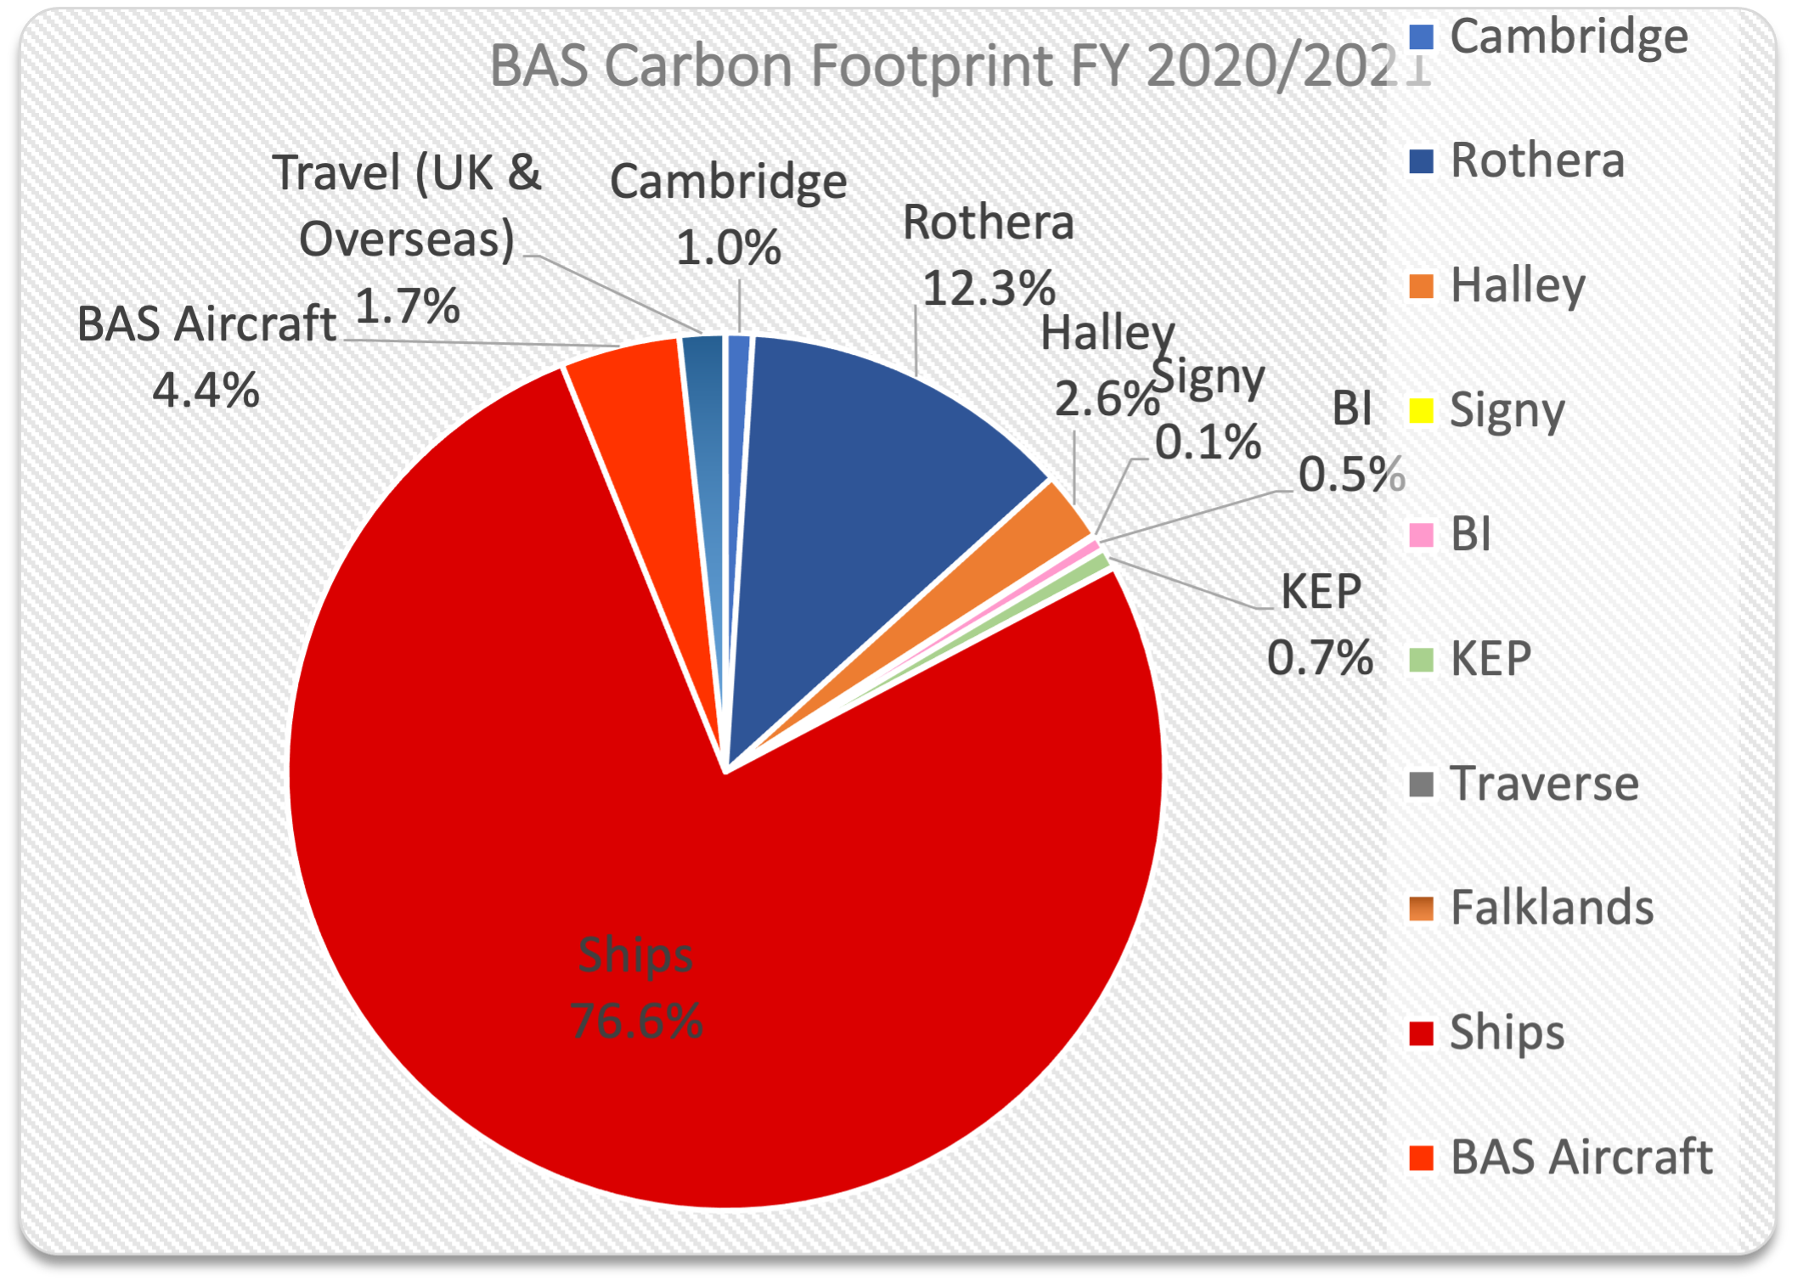

One widely cited study into the environmental impacts of food was published by Poore and Nemecek (2018), and reaches a number of interesting conclusions when considering the global food system as a whole. Firstly, producers are vital to reducing the climate impact of the food they grow or rear, which they can achieve by changing multiple production practices, monitoring the impacts they’re having (on land use change, water scarcity and other factors alongside GHG emissions), and communicating the changes they are making up the supply chain. However, the ability of producers to reduce environmental impacts is limited in isolation, and dietary changes (ie. changing the level of demand for different types of food) can deliver substantial positive impacts. For example, fully excluding animal products from diets could reduce land use from food by 76%; greenhouse gas emissions by 49%; acidification by up to 54%; and eutrophication by up to 56%. While these figures are estimates based on a full transition to plant-source foods, even reducing intake of animal-source foods can go a long way towards achieving these gains.

This year (2021) has already seen several key moments when it comes to analysing the food system. The National Food Strategy, published in July, took a detailed look at how the UK’s food system currently operates, and how changes can be made going forwards to ensure we are well-fed with enough of the right kinds of foods to live healthy and fulfilling lives (Dimbleby, 2021). It explored, among other things, the climate impact of the current food system, complexities around attributing carbon values to different foods and the impact of food waste. One recommendation was the strengthening of government procurement rules to ensure taxpayer money is spent on healthy and sustainable food; this will feed into the government’s promised Food Strategy white paper later this year, and eventually influence the purchasing decisions of BAS, positioning this report as a timely intervention.

Second, alongside the United Nations General Assembly week in New York in September, the UN Food Systems Summit was run with the recognition that “everyone, everywhere must take action and work together to transform the way the world produces, consumes and thinks about food”(UN, 2021). This summit recognised the importance of food to not only the climate challenge but many other social, economic and environmental challenges worldwide. Food systems can be linked to all 17 Sustainable Development Goals, and to achieve them will require a focus on healthier, more sustainable and more equitable food systems. In many ways, the goals of the summit are similar to those of this report, which can be seen throughout the text:

* Dramatically elevating public discourse about the importance of food systems
* [Achieving] significant action with measurable outcomes…including calls for new actions by different actors
* [Creating] a system of follow-up and review that will drive new actions and results while allowing for sharing of experiences, lessons and knowledge

Following on from these efforts will be the COP26 meeting in Glasgow in November, likely to also contain large amounts of discourse around food systems given their estimated contribution to total global greenhouse gas emissions of about 26% (surpassed as a sector only by energy production), and major contribution to other issues such as terrestrial acidification, eutrophication, water use and land use (Bouwman *et al.*, 2002; Poore and Nemecek, 2018).

It is clear then that food has a significant environmental impact. However, this must be balanced against the need to eat, availability and cost of different products, nutritional value and cultural and social factors among others. Each food system, farm and factory is slightly different, so the impacts of the same food from different sources will be different – sometimes substantially. In this work, every effort has been made to ensure the analysis relates as specifically as possible to the food BAS buys, and the sources it comes from to ensure it is as useful as possible. However, as data is rarely available at greater than a ‘country of origin’ level of detail, there will invariably be an element of ‘best guess’ scenarios and estimation. Nevertheless, the methods used provide results that are of a useful level of accuracy, as is explained in the next section.

# Research methods

Life cycle assessment (LCA) was the primary research methodology used in this project and is one way of evaluating the environmental impacts of a product over its lifetime. It involves breaking a product – in this case a type of food – down into its component parts in order to build up a picture of the contribution each stage of the production process makes to the final product’s climate impact (CI). CI is measured here in kilograms of carbon dioxide equivalent (kgCO2e) - this simply means that all greenhouse gases are expressed in terms of the warming effect of carbon dioxide.

When carrying out an LCA, system boundaries are imposed to determine what processes will be counted as part of the analysis (Cerutti *et al.*, 2014). In this report, the production stage is generally assessed with an ‘at farm gate’ system boundary, meaning all processes up to the food item leaving the farm are considered. Due to the complexity of carrying out a full LCA from scratch, and the significant technical and time resources this would require for each item of food, the approach used here is to use average CI for each food type as found in the academic literature. These data are then applied to a ‘basket of goods’ which include at least the top 20 most ordered types of food (by weight), determined from the 2020 Rothera food order sheets. This approach has been used by other researchers to examine wider food systems, and ensures a representative sample of products contributing the vast majority of greenhouse gas emissions are considered (Notarnicola *et al.*, 2017; Roy *et al.*, 2009). As this approach does exclude some items, it should be noted that final figures are therefore best estimates, particularly where items that could have a potentially high CI but low weight have been excluded (such as coffee). Nevertheless, with the constraints of the project and precedent in the academic literature, this was the approach selected as most suitable.

Though many studies were used in the analysis, one in particular proved useful in many sections as the researchers (Clune *et al.*, 2017) had collated a list of all available LCA studies for each food item and used this to make best estimates of CI for a wide variety of products. Where a product was ordered by BAS, but had not been covered by Clune et al., other studies were used instead; likewise, if a large number of studies had been conducted into one particular product (as was the case with cheeses, for example), then multiple studies are cited with averages taken (if appropriate) to determine a best estimate for the products’ true CI. Where there was truly no academic data available on certain products, as a last resort data from UK supermarket Tesco’s own analysis of their products was used to form an estimate (Tesco, 2012).

The following section details the main body of the research, starting with the production phase, for which the food is split into dried and frozen goods, before moving on to the transport and other phases of the food lifecycle.

# Results

The foods we consume can have a significant environmental impact associated with the GHG emissions released throughout their lifecycles. There can be substantial differences in what might be called the ‘embedded’ carbon of different foods (that is, the carbon required to grow a type of food from birth or from seed to the point that it is harvested or slaughtered ready for consumption). Here we explore the impacts of various foods sent to Rothera in the 2020 season to the point where they are delivered to British Antarctic Survey processing facilities in the UK.

## Frozen food

### Beef, Lamb and Pork

BAS purchasing data shows that 2101.2kg of frozen beef was ordered in 2020. Values in the literature for the exact climate impact (CI) for beef vary, but for the purposes of this analysis Lesschen *et al.* (2011) reached a value of 22.6kg CO2e- for the EU27 countries (which included the UK at the time of the study). Clune *et al.* (2017) determined that 25.76kg CO2e- was the average for the UK, so taking the average of these two figures - 24.18 – we arrive at an estimate of 50807kg CO2e- for the 2020 beef order.

Additionally, 1050kg of lamb was ordered in 2020. Using the 25.84kg CO2e- value reached by Clune *et al.* (2017), an estimate of the CI from lamb is reached at 27132kg CO2e-. There can be significant variation in the CI of British lamb depending on its source, shown in a comparison of two Welsh sheep farms by Edwards-Jones *et al.* (2009) in which one farm was estimated to produce lambs at 13kg CO2e- while another was estimated at 52kg CO2e-. The figure used in the analysis above takes into account upland and lowland farming methods and the results of multiple studies to estimate a UK average figure which it is determined is the best solution to this issue.

Continuing with the meat, a total of 3219kg of pork was ordered, comprised of 780kg of various cuts of pork (eg. loin steaks, bellies), 1000kg of bacon, 1271kg sausage meat and 168kg cured meat (hams etc). Pork has a significantly lower CI than beef or lamb at 6kg CO2e-, leaving us with a total of 19314kg CO2e- from the 2020 order (Clune *et al.*, 2017).

### Poultry

In general, poultry has a much lower CI than red meat, largely due to it being non-ruminant in nature and therefore lacking output from the enteric fermentation process found in, for example, cows. It is perhaps not surprising, then, that the 1200kg of chicken ordered in 2020 resulted in 4994kg CO2e- when an estimate for CI of 4.12kg CO2e- is used (Clune *et al.*, 2017), which is much lower when compared with the values for red meat.

Chicken sits at the midpoint of poultry in terms of CI; the 80kg of duck produced 247.2kg CO2e- at a lower average of 3.09kg CO2e-, and the 150kg of turkey was more comparable to pork at 6.04kg CO2e-; this resulted in a CI of 906kg CO2e- (all CI estimates from Clune *et al.*, 2017).

### Dairy products

A total of 1325kg of cheese was ordered in 2020, of which 440kg was cheddar in various forms. While popular, this is also one of the most carbon intensive types of cheese, producing a CI of about 13kg CO2e-. Cheddar alone therefore contributed 5720kg CO2e- to the total (Gosalvitr *et al.*, 2021). For the remaining 885kg of other cheeses, such as feta, halloumi and mozzarella, a CI value of 8kg CO2e- has been used, based on data from Canellada *et al.* (2018) and Finnegan (2017). This yielded a total of 7080kg CO2e-, meaning cheese as a whole had a CI of 12800kg CO2e-.

Not far off this figure is the 1250kg salted & unsalted butter from the 2020 order. At 7.6kg CO2e-, which is an average of the 3 British data sources used in Clune *et al.*'s (2017) study, we reach 9500kg CO2e-, demonstrating the relatively high CI of common dairy products.

### Fish & seafood

In total, 1598kg of frozen seafood products were ordered in 2020. This included 736kg of cod, haddock and salmon (200kg of cod and salmon, 336 of haddock). These species have been grouped together due to similar emissions from the three of around 3.4kg CO2e-, giving a total CI of 2502.4kg CO2e-. These species have roughly double the CI of the average fish species.

A further 259kg of pollock and 205kg of hoki fish at 1.7kg CO2e- each results in a total of 788.8kg CO2e- for both species. All data on fisheries uses the industry average for the EU determined by Parker *et al.* (2018), which agrees with conclusions reached by Clune *et al.* (2017).

Finally, 303kg of processed fish fingers and fish cakes, which it is assumed are cod or haddock, add 1030.2kg CO2e- to the total.

### Other animal source foods

A large number of eggs – assuming medium sized eggs weighing 60 grams, 8733 of them – were ordered at a total weight of 524kg. Note that of this total, 400kg were whole eggs and the remainder were whites or yolks that were already separated (all frozen). They are treated here as whole eggs due to a lack of available data for the difference in CI this would result in. Leinonen *et al.*'s (2012) study looked at eggs produced in cages, barns, free range and organic (the four main production systems in the UK), and the average of all these is 3.29kg CO2e- per kg of eggs produced. This results in a total CI of 1725kg CO2e- for the egg order.

### Potato products

Surpassed by weight by only pork-based products, 3000kg of fried potato products including French fries, hash browns and wedges were ordered in 2020. While a study specifically investigating UK production of these items has not been conducted, estimates of Swiss and Dutch French fry production (including the frying process) yield results of about 2kg CO2e- (Mouron *et al.*, 2016; Ponsioen and Blonk, 2011). It is thought the differences between this and UK figures is likely small, so using this figure we get 6000kg CO2e- CI from these items (this is significantly higher than the value for potatoes ‘at farm gate’ due to the energy used in the frying and production process).

### Vegetables

In 2020, 4292kg of frozen vegetables were ordered of which the most popular 2880kg by weight can be seen in table 4.1 below. This provides an overview of the CI of the most ordered frozen vegetables and omits only those of which little was ordered or no data was available.

|  |  |  |  |
| --- | --- | --- | --- |
| **Vegetable** | **Amount (kg)** | **Kg CO2e-/kg** | **Total kg CO2e-** |
| Asparagus | 100 | 0.92 | 92 |
| Carrots | 400 | 0.22 | 88 |
| Beans (green & broad) | 350 | 0.51* | 178.5 |
| Broccoli | 350 | 0.7 | 245 |
| Cauliflower | 280 | 0.35 | 98 |
| Mixed vegetables | 350 | 0.47** | 164.5 |
| Mushrooms | 400 | 0.27 | 108 |
| Peas | 300 | 0.6 | 180 |
| Peppers | 350 | 1.08 | 378 |

***Table 4.1:*** *quantity ordered and CI for frozen vegetables ordered by BAS in 2020*

*data not available for broad beans so the value for green beans has been applied

**overall average for field-grown vegetables used

*CI data from Clune et al. (2017)*

From table 4.1 it is clear that some vegetables, such as broccoli and peppers, have a much higher CI than others, but that all are well below the values for animal source foods presented above. The total CI for the 2880kg analysed was 1311kg CO2e-.

### Mycoprotein

Data on the climate impact of meat substitutes such as mycoprotein (the main component in Quorn branded meat substitutes) is fairly limited, however from the few studies that have investigated a figure of 2.5-5.5kg CO2e- is reached (Smetana *et al.*, 2015; Souza Filho *et al.*, 2019). If we use the midpoint of this range to assume a value of 4kg CO2e- per kg mycoprotein, then the 350kg of Quorn-branded products ordered in 2020 would yield a carbon impact of 1400kg CO2e-. This is similar to the per-kg impact of chicken, one of the most carbon efficient meats to produce. However, analysis conducted by The Carbon Trust in partnership with Quorn gives a figure of 0.79kg CO2e- for the actual mycoprotein and between 1-2kg CO2e- for most finished Quorn products (The Carbon Trust, 2021). How this conclusion is reached is not clear and as the report is not from the peer-reviewed literature the 4kg figure from the studies above has been used here, but this demonstrates the variability in results from different analyses and clearly if a figure of 1kg CO2e- for mycoprotein is used, the resulting carbon impact of 350kg CO2e- for Quorn is just 25% of the result quoted above, a substantial difference.

## Dry food

### Milk and cream

A CI value of 1.2kg CO2e- for dried milk products was used, obtained from March *et al.* (2021) who analysed four UK production systems; this is slightly less than the global average of 1.39kg CO2e- determined by Clune *et al.* (2017). A total of 486kg of powdered milk was in the 2020 order, giving a total CI of 583.2kg CO2e-.

Cream has a significantly higher CI than milk, reflected in the higher CI of the 480kg UHT cream ordered in 2020. Data is scarce, but data from UK supermarket Tesco suggests a 4.4kg CO2e- value for cream, which roughly fits in with a global average of 5.32kg CO2e- put forward by Clune *et al.* (2017). Using this value would result in a total CI of 2112kg CO2e-, though as this data is for fresh cream rather than UHT, which requires an energy-intensive process to transform the product into a long-life version, the true value is likely to be higher.

### Flour

Large quantities of flour were ordered in 2020; namely 1760kg bread flour and 480kg self-raising flour. The results from three UK studies analysed by Clune *et al.* (2017) give an average of 0.67kg CO2e- for British wheat; data from Espinoza-Orias *et al.* (2011) suggest that the milling process contributes only a little more carbon to make flour, hence here a figure of 0.7kg CO2e- is used for flour. This results in a total CI of 1568kg CO2e-, with the assumption that self-raising flour contributes a negligible difference in carbon during its production process.

### Tinned vegetables

Of the large number of tinned vegetables ordered, a few stand out for the high quantity requested, and these are the ones analysed here. Baked beans, of which 1192kg were ordered, proved problematic to produce a figure for CI due to a lack of peer-reviewed literature focusing on this particular product. However, an internal report conducted by UK supermarket Tesco in 2012 and subjected to an external audit came up with a figure of 1.4kg CO2e- for each kilogram of baked beans (Tesco, 2012). Using this figure, it is estimated that 1668.8kg CO2e- can be attributed to baked beans, but for the above reasons this may be a slightly inaccurate figure (emissions from retail and disposal are included in this data whereas most other figures in this report are ‘at farm gate’ statistics).

Mushrooms have a relatively high CI of 2.44kg CO2e- according to Frankowska *et al.* (2020). This figure is for fresh, not tinned mushrooms, so is likely to be slightly inaccurate given the contribution of packing to overall carbon footprint for tinned foods – this could be estimated using the method outlined below. It is also assumed that button mushrooms and sliced mushrooms from the same supplier have the same CI. The 1023kg ordered therefore had an estimated CI of 2496kg CO2e-.

Del Borghi *et al.* (2014) estimate that 1.47kg CO2e- is the CI for a kg of chopped tomatoes (assuming 400g tins). Over 50% of this value is attributed to the packing (ie. the tin), demonstrating the carbon importance of packaging. We can use this figure to estimate that the 1200kg of chopped tomatoes ordered in 2012 have a CI of 1764kg CO2e-.

Of all the tinned vegetables, potatoes had the highest quantity by weight at 3000kg. Due to a lack of data on the CI of tinned potatoes, a novel approach to determining this value has been adopted (fresh potatoes have a relatively very low CI compared to other vegetables of 0.2kg CO2e-, but the tin packaging will greatly increase the overall CI so must be calculated in this case). Using data on tinned tomatoes from Del Borghi *et al.* (2014), we can determine that an 800g tin has a CI of 0.57kg CO2e- per kg of packaged product. The same product (peeled tomatoes in this case) in a 400g tin has CI of 0.69kg CO2e-, so the relationship between tin size and CI is non-linear. The potatoes in question come in 2.5kg tins, so a line is plotted in figure 4.1 to estimate the CI of a tin this size. The result is an estimate of approximately 0.42kg CO2e- per tin. As 1200 tins were ordered, the total CI of the tins is estimated at 504kg CO2e-. Added to the 600kg CO2e- from the potatoes themselves gives us a total estimate of 1104kg CO2e-.

**Figure 2:** Potential CI associated with production of a 2.5kg tin

Figure 4.1: Potential GWP associated with production of a 2.5kg tin

yyyyd

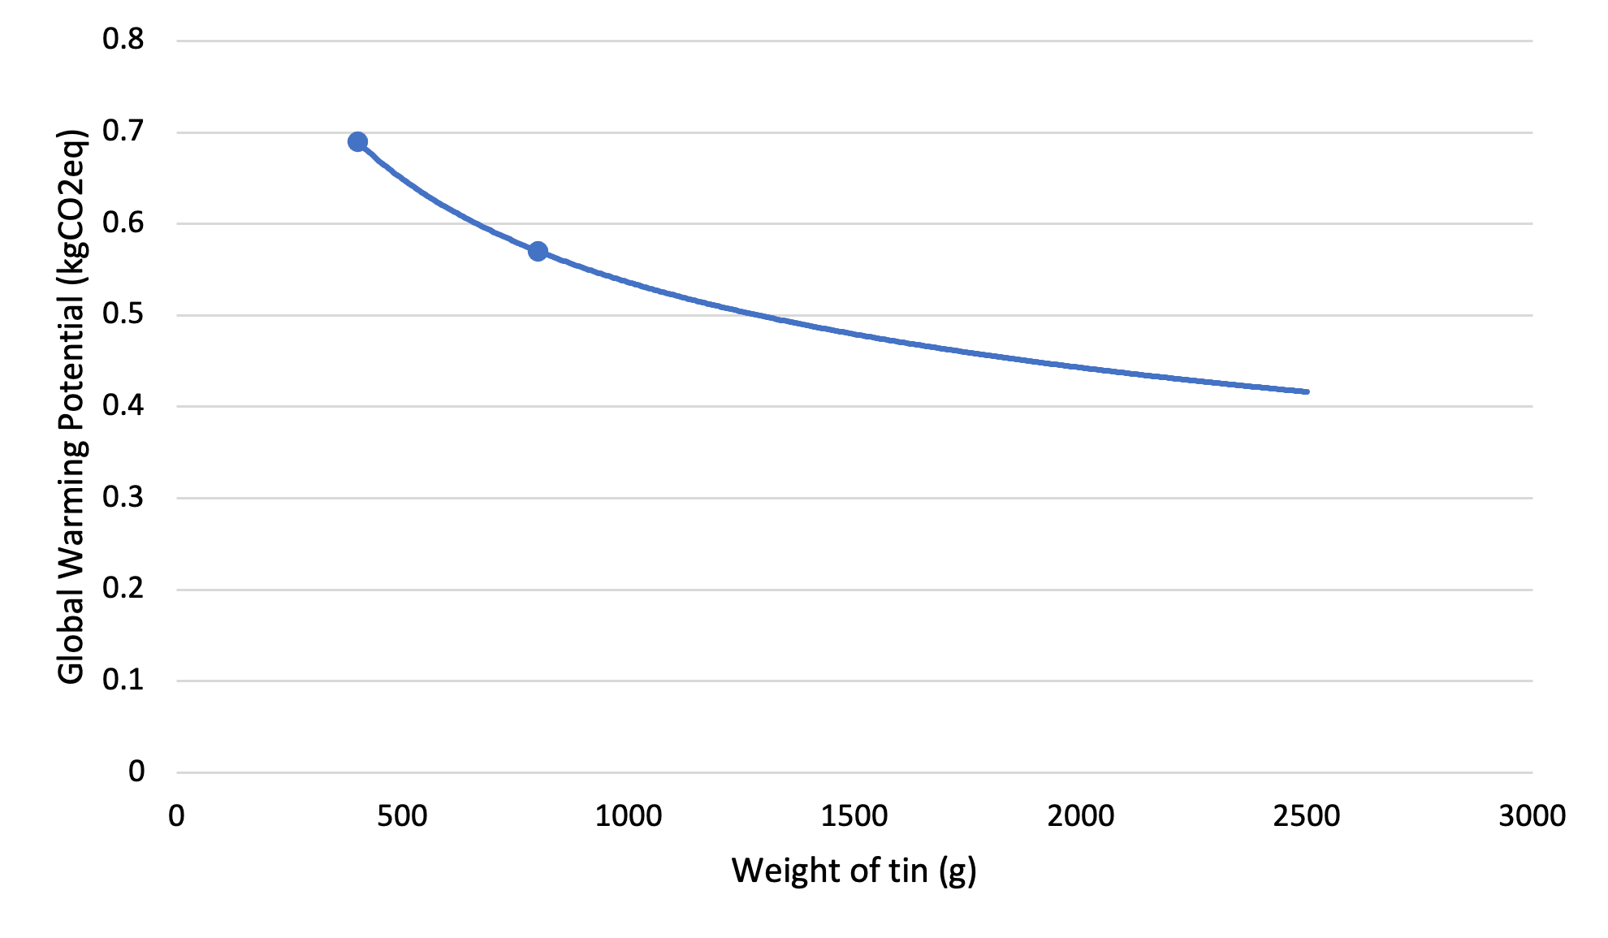

### Beverages

Large amounts of beverages were requested in the 2020 order, particularly of carbonated soft drinks. The greatest quantities were Irn Bru cans (317 litres), Coca Cola (950 litres each of diet and standard), Lemonade (475 litres), assorted Dalston’s beverages (total of 2851 litres) and Red Bull (360 litres). All of these come in 33cl cans, apart from Red Bull which comes in non-standard 25cl cans. As no data is available for the 25cl can size, it is assumed that all drinks are in 33cl cans and have the same production emissions (Amienyo *et al.* (2013) note that all carbonated soft drinks contain water, sugar, carbon dioxide, an acid and a flavouring, so production emissions should be similar). Data from Amienyo *et al.* (2013) suggests that carbonated soft drinks in a 33cl can have a CI of 0.312kg CO2e- per litre. The 5903 litres outlined above are therefore estimated to have a CI of 1842kg CO2e-.

Significant quantities of fruit squashes were also ordered – 1140 litres in total. Data for these products is scarce but using the Tesco data cited previously a figure of 0.346kg CO2e- per litre can be found based on figures for no added sugar orange squash. This results in a total of 394kg CO2e- for squashes.

### Wine

600 litres of red and 480 litres of white cooking wine were ordered in 2020. A review of numerous life-cycle assessments by Rugani *et al.* (2013) finds an average CI per 750ml standard bottle of wine of 2.2kg CO2e-, but with an error of ±1.3kg CO2e- given the large variation in production techniques worldwide. However, packaging processes make up a large proportion of this estimate, and the Country Range cooking wine delivered to BAS comes in 3 litre cartons rather than 750ml glass bottles as assumed in most studies. On average packaging and end of life processes contribute about 1kg CO2e- to the total above, so for the purposes of this analysis an estimate of 1.2kg CO2e- per litre (given the above values are for 750ml but the product delivered to BAS is a significantly larger 3 litres) is used. This results in a CI estimate of 1296kg CO2e- for the cooking wine.

### Cooking oil

A total of 1107 litres of cooking oil was ordered in 2020, comprised of 891 litres of corn oil and 216 litres of sunflower oil. Data is scarce on the CI of cooking oils, with the literature instead focusing on the potentials for used cooking oil to be refined into biofuels. However, a 2020 study from Alcock *et al.* (2020), which has yet to be peer reviewed, found that the average of European sunflower oil production resulted in 1.63kg CO2e- per litre of oil produced. No data was available for corn oil. Applying this figure for CI to all the cooking oil results in a total of 1804kg CO2e-, but this figure should be used cautiously as the difference in CI between corn and sunflower oil is unknown so is therefore simply a best estimate.

## Fresh food

A limited amount of fresh food is sent to Rothera each season via ship and aircraft from South America. Records from the 2020/21 season show that each shipment contains anywhere between about 100-500kg of fresh food, further complicated by the possibility that food loaded on to the ship may or may not be for consumption on board the ship, at Rothera, or at one of the other stations – data on this was not readily available. Furthermore, the CI of this food is likely to vary significantly depending on method of transport (ie. ship or aircraft), and in any given season the number of shipments both in total and by each transport method will also vary. The types of food sent in each shipment varies substantially too, aside from a few common items regularly ordered. Because of these factors it has been determined that were an estimate of CI from fresh shipments to be made, it would likely contain a very high degree of inaccuracy. Assuming all fresh food loaded in South America in 2020/21 was consumed at Rothera – again, highly unlikely – it would still only make up around 1% of the total food sent to the station that season. Therefore an estimate is not provided here, but the contribution of fresh food acknowledged and identified as an area for further investigation in the future.

|  |  |  |  |
| --- | --- | --- | --- |
| **Food type** | **kgCO2e-** | **kg/litres ordered** | **GWP (CO2e- per kg)** |
| Lamb | 27132 | 1050 | 25.84 |
| Beef | 50807 | 2101.2 | 24.1799924 |
| Cheese | 12800 | 1325 | 9.66037736 |
| Butter | 9500 | 1250 | 7.6 |
| Turkey | 906 | 150 | 6.04 |
| Pork | 19314 | 3219 | 6 |
| Cream (powder) | 2112 | 480 | 4.4 |
| Chicken | 4994 | 1200 | 4.16166667 |
| Mycoprotein (quorn) | 1400 | 350 | 4 |
| Processed fish | 1030.2 | 303 | 3.4 |
| Cod/haddock/salmon | 2502.4 | 736 | 3.4 |
| Eggs | 1725 | 524 | 3.29198473 |
| Duck | 247.2 | 80 | 3.09 |
| Pollock/hoki | 788.8 | 259 | 3.04555985 |
| Mushrooms | 2496 | 1023 | 2.4398827 |
| Fried potatoes | 6000 | 3000 | 2 |
| Oil (cooking) | 1804 | 1107 | 1.62962963 |
| Tomatoes (chopped) | 1764 | 1200 | 1.47 |
| Baked beans | 1668.8 | 1192 | 1.4 |
| Milk (powder) | 583.2 | 486 | 1.2 |
| Wine (cooking) | 1296 | 1080 | 1.2 |
| Flour | 1568 | 2240 | 0.7 |
| Frozen veg | 1311 | 2880 | 0.45520833 |
| Potatoes | 1104 | 3000 | 0.368 |
| Fizzy drinks/squash | 2236 | 7043 | 0.31747835 |
| Total | 157089.6 | 37278.2 | n/a |

**Figure 3:** Categorised summary of food production data

*note that colours from fig.3 correspond to their constituent food types in table 2

**Table 2:** Summary of food production data

**Figure 4:** GWP of all food categories adjusted for amount ordered (graphical representation of kgCO2e- data in table 2)

## Transport

The vast majority of emissions related to food transported to Rothera result from the RRS Sir David Attenborough (SDA), from which three sources are investigated. The first is fuel burn from the ship itself; the total weight of food ordered in 2020 was 68301kg, which takes up 1.5% of the SDA’s total cargo capacity. Therefore, 1.5% of the total emissions from the ship’s engines was used to estimate the fuel burn attributable to food. This is calculated at 8288 litres of marine gas oil (MGO) for the 32-day journey from the UK to Rothera which, when using the UK government’s conversion factor of 2.775kg CO2eq for that fuel type results in a total of 22833kg CO2eq.

Secondly, as much of the food is frozen and must be kept that way for the journey, emissions resulting from ‘reefer’ (refrigerated shipping container) power use can also be considered. Using an estimated power consumption of 2.7kW (Fitzgerald *et al.*, 2011), and taking into account the type of generators on the SDA, their efficiency and the type of fuel used, a figure of 864.6kg CO2eq is reached.

Lastly, refrigerant gas leaks can, depending on their size and the type of gas, have a significant warming effect. UK government guidance suggests using a figure of 39% annual leakage rate for marine transport refrigeration. The reefers that travel on the SDA use refrigerant R452A which, over the 32-day journey, can be estimated to leak gas with a GWP of 292.68kg CO2eq.

Combining the total from these three areas gives a total transport emission estimate of 23990.28kg CO2eq.

**Figure 5:** Distribution of global warming effects from food transit

## Storage

The impact of storing food at Rothera is evaluated here. Given emissions from storing food are primarily energy use from freezers, they are the focus of this section.

|  |  |  |  |  |
| --- | --- | --- | --- | --- |
| **Location** | **Type** | **Quantity** | **CI from gas leakage (kg CO2e)** | **CI from power use (kg CO2e)** |
| NBH kitchen | Food fridges | 2 | 13.73 | 452.6 |
| NBH dining room | Small fridges | 2 | negligible | 247.5 |
| NBH | Walk in storage (small) | 2 | 99.42 | 8727.6 |
| Fuchs house | Walk in storage (large) | 3 | 282.38 | 21334 |
| Static reefers | Reefer | 4 | 941.28 | 34910.4 |
| **Total** | **-** | **13** | **1336.81** | **65672.1** |

*NBH = New Bransfield House

**Figure 6**: Climate impact from refrigeration units at Rothera

Table 6.1: GWP from refrigeration units at Rothera

Table 6.1: GWP from refrigeration units at Rothera

Table 6.1: GWP from refrigeration units at Rothera

The above data on gas leakage has been calculated using the UK government’s tool for estimating greenhouse gas emissions. This involves using the following equation: [number GWP from of units] refrigeration x [equipment units at charge Rothera capacity (kg)] x [time used during reporting period] x [annual leak rate % (standardised figure based on equipment type)] x [global warming potential of refrigerant], as described in Annex C of the Environmental Reporting Guidelines (HM Government, 2019). Data on the equipment at Rothera, charge capacity and refrigerant used is taken from the Rothera Annual F Gas Report 2020 (BAS, 2020).

Based on data from April – July 2021, the four on-station generators from which Rothera gets most of its power were providing an average output of around 98kW each, at which each generator can be expected to burn around 26 litres of fuel each hour (Volvo penta, 2011). They run on marine gas oil (MGO), the conversion factor for which is around 2.78kg CO2e per litre. Each generator therefore produces about 72.3kg CO2e per hour, or 0.738kg CO2e per kWh.

Freezer duty cycles mean that the compressor does not run constantly; various studies estimate anywhere between about 50-70% of total energy rating is utilised (Bagheri et al., 2016; Mudie et al., 2014). The Fuchs house walk-in freezers were installed in 2017, so are assumed to be reasonably efficient. Therefore a 50% power use compared to the total rating of 2.2kW is assumed, giving 1.1kW as the average power consumption figure (Rivacold, n.d.). The 3 freezers for an hour therefore use 3.3kWh of energy, so over a year we can attribute 21334.1kg CO2e to those freezers. Using a similar process, we get the other data in table 6.1. The walk-in fridge and freezer in NBH have, combined, about the same refrigerant charge and use the same refrigerant as one of the Fuchs freezers so these are calculated as equal to one Fuchs freezer.

For the reefers, the same estimation of average power consumption is used as in section 5 at 2.7kW per reefer. Studies have shown that mean ambient temperature generally has little impact on energy usage (Evans et al., 2014). However, one would assume that such studies did not consider the impact an average ambient temperature of -4oC – as it is at Rothera – would have on energy usage (BAS, 2012). This is tricky to estimate given a lack of research on maintaining a constant freezer temperature in freezing ambient conditions. It would be reasonable to assume it had a significant impact. If the reefers are maintaining a temperature of -20oC and the ambient is -4oC compared to an annual mean of about 10oC in Cambridge, UK (Met Office, n.d.), then one might assume that at Rothera it required about half the energy to cool to the same temperature as it would in the UK. Whether this relationship is linear or not is also unknown, but assuming it is the total emissions from reefer energy use would reduce to about 17455kg CO2e, clearly a large difference that would significantly alter the results presented here.

Making calculations on the assumption ambient temperature has little impact on energy use, we can see from table 6.1 that the total climate impact of storing food at Rothera for a year is estimated at 67008.9kg CO2e.

## Cooking

It is important to consider the emissions resulting from the preparation of food which mainly come from the electricity used by cooking appliances. Metering data from New Bransfield House (NBH), where the kitchen is located, is used to provide an estimate of the energy consumption for this purpose. Average daily energy consumption at NBH can be seen in figure 7.1; as one would expect, there is noticeable variation between the Austral summer and winter when the number of people on station greatly varies (time=1 is January 1st, time=365 is December 31st).

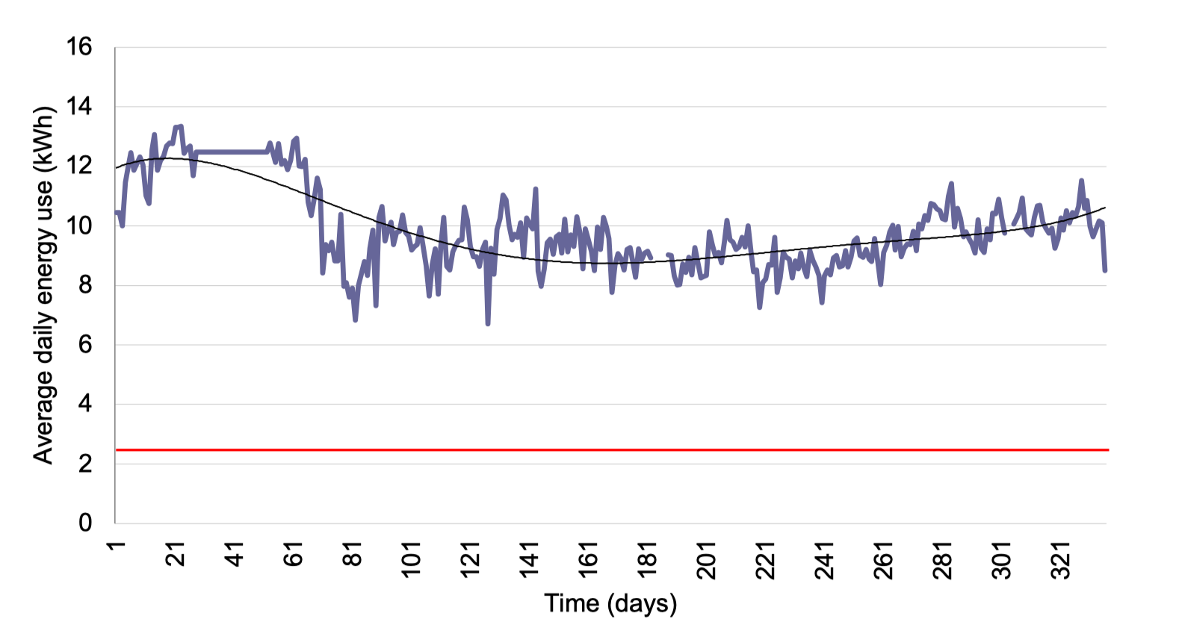

**Figure 7.1:** average energy consumption at NBH over a year

Background power usage comes from a few sources – refrigeration is one of these, denoted by the red line with an assumed constant energy use of 2.35kWh (data from section 6). This becomes clearer when observing the half-hourly metering data in figure 7.2, taken from the month of December 2017, for which the average is taken in figure 7.3.

The background rate of energy use can clearly be seen here between the hours of 20:00 – 0600 when no cooking activity is occurring. The kitchen opens at 6am to pre-heat the ovens, which is when the energy demand begins to increase. This leads to the first peak – ‘A’ – around 8am which it can be assumed corresponds with breakfast. Likewise, ‘B’ at around 1pm is lunchtime, and peak ‘C’ around 7pm is dinner. We can see that the period during the middle of the day (around 0600-2000) demands a higher average energy output than overnight; this difference is depicted by the lines labelled ‘peak’ and ‘base’ in figures 7.2 and 7.3, which are at the same level in both figures. This ‘extra’ daytime demand sits between

about 7 and 13kWh, a difference of 6kWh. Other electricity demands in NBH are lighting, ventilation (mostly for the kitchen) and a computer room.

**Figure 7.3:** average half-hourly metering data for NBH, December 2017

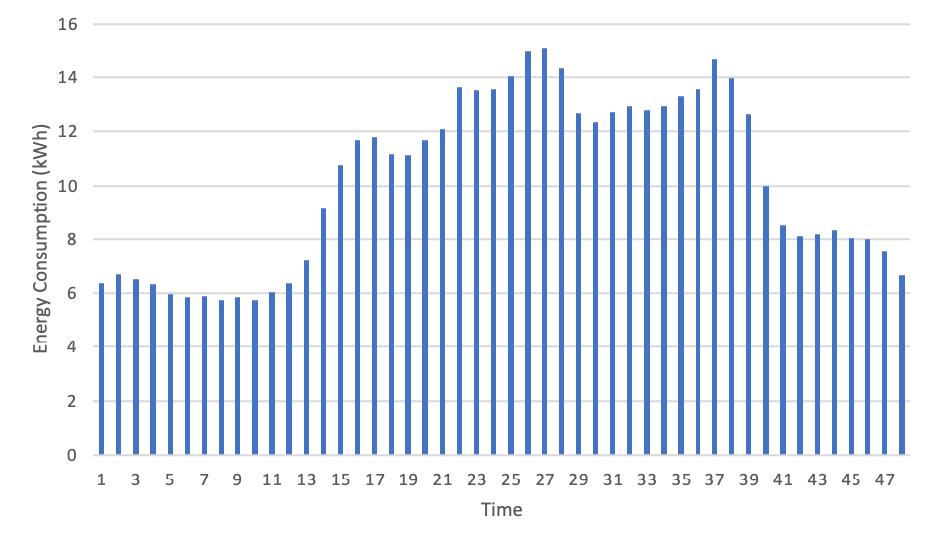

A

C

B

Peak

Base

**Figure 7.2:** half-hourly metering data for NBH, December 2017

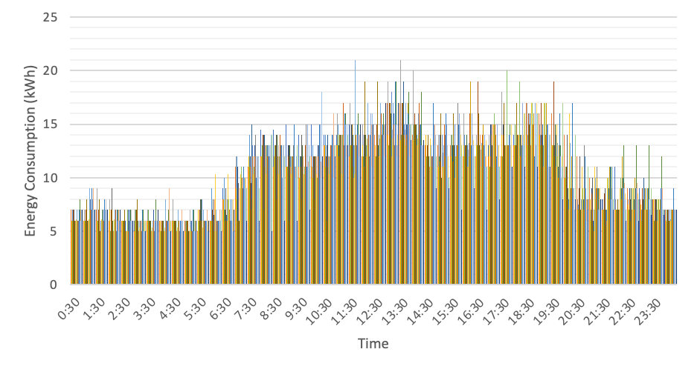

Peak

Base

Assuming all of the daytime electricity demand is used for preparing and cooking food, the kitchen equipment would draw about 6kWh. Over the 14-hour period of higher daytime use, this equates to 56kWh/day. Using the same method as in section 4.5, we can therefore estimate yearly CI due to cooking of food to be 5110kg CO2e.

## Waste

Due to Rothera’s remote location and limited facilities for processing waste, most non-hazardous waste is removed from the station and returned to the UK. Some items are disposed of on-station in an incinerator however. This primarily burns food waste and sewage, with quantities of both varying throughout the year as the station has up to 150 people in summer and only about 20 in winter. The incinerator is fuelled when conditions allow with marine gas oil (MGO), but this is mixed with aviation turbine fuel (which has a lower freezing point) in colder temperatures to reduce the chance of the fuel freezing. These fuels have a similar CI of 2.78 and 2.54kg CO2e per litre respectively; with the average being 2.66kg CO2e per litre, this is figure used in the following analysis.

Incinerator logs from 2019/20, the most recently available, were used to generate an estimate for the total amount of waste food burnt and fuel used per burn. As this data was drawn from handwritten logs, and figures (particularly weight of food burnt) were themselves estimates from the incinerator operators, fairly large inaccuracies are likely to be present. However, given this is the best data available, it is suitable for use here. A total of 6792kg of food waste was incinerated during the 12 months in question, 10% of the total sent to the station. 31 burns occurred over the period using an average of approx. 130 litres per burn (again, based on operator estimates). This results in an average per burn of 345.8kg CO2e, and an annual total 10719.8kg CO2e. While sewage is also burnt in the incinerator, food is (almost always) incinerated alongside so it is determined this figure can be attributed to disposal of food waste.

## Summary

|  |  |
| --- | --- |
| **Life-cycle stage** | **CI kgCO2e** |
| Production | 157090 |
| Transport | 23990 |
| Storage | 67009 |
| Cooking | 5110 |
| Waste | 10720 |
| **Total** | 263919 |

**Figure 8:** This table and chart show the distribution of total greenhouse gas emissions between the different stages of the food life cycle analysed in this section.

# Recommendations

Based on the above research, several conclusions can be reached regarding greenhouse gas emissions in the Antarctic food supply chain. With the production stage contributing 60% of overall emissions, it is clear that the *type* of food chosen has the largest impact and therefore the largest emission reduction possibilities. Contributing 25%, storage of food is, perhaps surprisingly, rather high – there is certainly scope for reducing this figure as well. Based on insights gained through the course of this research and the results presented above, the following six key recommendations are made for reducing food-related emissions.

1. **Decarbonise food order** – this can be achieved by reducing the amount of red meat and dairy products ordered, and replacing with lower carbon alternatives such as poultry, fish and, ideally, more vegetarian and plant-based alternatives, building on the 20% red meat reduction already proposed. Although a move to plant-based foods would have the largest impact, switching from red meats to chicken and pork would also generate substantial carbon savings for those not prepared to change their diets.
2. **Audit supply chain** – work with suppliers to ensure a clearer understanding of the origins of purchased food and develop or enhance sustainability policies at all levels of the supply chain to confirm shared objectives between BAS and suppliers. This is a key weakness of food procurement currently and is closely linked to the practices of suppliers. Carrying out or obtaining a carbon audit of the main producers supplying BAS would identify further discrepancies *within* food categories and, were less carbon intensive suppliers identified and used instead, supply chain emissions could be reduced even independently of a change in food order described above.
3. **Improve environmental recording** – in future years streamline records to facilitate easier reporting of carbon values to enable progress tracking. For example, include climate impact on order spreadsheets using a similar method to that employed in this study, and ensure more specific and accurate monitoring of energy use across all food related processes (refrigeration, incineration etc.). Action on reducing emissions will only be effective if progress can be measured over time, and this can only happen with easily interpreted, scientifically grounded data.
4. **Named environmental champion for food** – incorporate responsibility for tracking progress on food related emissions into a named person’s job description to facilitate sustained progress in this area. As will be discussed in the next section, several experienced BAS employees identified a lack of joined-up thinking as a major barrier to reducing food emissions across the organisation. Having a named person ensure consistency across seasons could reduce issues caused by new chefs and different practices between stations each season.
5. **Pre-deployment training** – review existing training for those going to the Antarctic to ensure sufficient coverage is given to the impacts of food choices and wastage on-station. Provide chefs with additional training on a rolling basis on low-carbon cooking to ensure climate-friendly meal options are as attractive and varied as possible to encourage uptake. If non-meat options are plentiful, delicious and varied their uptake is more likely to be accepted and accelerated by those living on station.
6. **Further research** – revisit this study and build on it in future years when improved data is available. This may include, for example, real-life data on SDA operational efficiency one it has been in use for several seasons, reefer energy use (data collection already scheduled for Austral summer 2021/2) and fresh food transports, which are currently recorded on an ad-hoc basis. Future studies could further investigate emissions of other stations besides Rothera, on-ship catering, the impact of the Antarctic Infrastructure Modernisation Program on energy efficiencies at Rothera and the viability of composting/digesters and hydroponics on-station.

This list is by no means comprehensive, and neither should each recommendation be taken in isolation. Rather, the greatest positive impact will result from their implementation alongside each other. There also exists the possibility for further benefits beyond reducing BAS food-related emissions. For example, if a carnivore is exposed to a wide range of attractive vegetarian dishes while in the Antarctic, they may be persuaded to reduce their meat intake at home as well, creating a knock-on impact. While such benefits are impossible to quantify, they would undoubtedly further contribute to wider emissions reductions creating benefits beyond the immediately obvious.

Food can often be a contentious subject, particularly when changes to food provision are suggested, and acceptability is an important part of successful implementation in such cases. In recognition of this, interviews with a number of BAS staff experienced in different areas have been carried out to try and identify the most effective methods to implement change. The findings of these conversations have fed into the recommendations above, and are summarised in the next section.

# Interviews – challenges and opportunities for implementation

Four short interviews were conducted with people from various backgrounds, all of whom have spent time at various Antarctic stations, to identify some of the likely obstacles to a change in the food provision but also opportunities likely to present themselves from the implementation of the above recommendations. These interviewees are identified as I1-4 for the purposes of this chapter.

One theme that could be drawn out quite clearly from every conversation was a feeling that the organisation as a whole is generally quite resistant to change. This could be a cause for concern given the objectives of this report, but given the wider environmental context it is clear some changes will be needed. One way to encourage acceptance of the recommendations above could be to frame them not as ‘change’ but as improvements or increases in efficiency, and – as suggested by I1 – introducing them over time rather than as an immediate shift in long-held practices. This is likely to be the case anyway due to the large stockpiles held at Rothera and elsewhere taking several seasons to respond to a change in the contents of the yearly resupply. Changing the availability of certain types of foods is likely to meet the most resistance, but as we have seen in previous sections this is where the greatest potential for emissions reductions lie. I3 noted that the mixture of attitudes among those in the Antarctic can sometimes create clashes, but that changes over time may even go unnoticed by many, particularly given the high turnover of workers each season.

Reducing the provision of certain foods like beef and lamb may actually be welcomed by many; both I3 and I4 commented on the relatively high amounts of red meat in their diets while in the Antarctic compared to their diets at home. I2 also noted that on the smaller island stations, too much red meat is provided compared to, for example, chicken, which tends to be underprovided compared to demand. Additionally, the vegetarian catering was generally agreed to have improved substantially in recent years so that non-vegetarians are now able to choose a vegetarian meal if they wish whereas just a few years ago these meals were reserved for those who were specifically vegetarian (though at smaller stations this is still common practice). I3 also noted that particularly scientists, who have been working in a lab or office rather than outdoors are often keen for a lighter vegetarian meal. I1, I2 and I4 all commented that they would like to see more chicken and fish options in place of red meat options, which on reference back to table 2 we can see could reduce emissions by up to 5-6 times.

The limitations of cooking in an environment like the Antarctic inevitably came up, particularly in relation to the fact that people are stuck eating what the chefs provide as there are no alternative sources of food, and therefore there must be a wide range that appeals to everyone. This links to a point made by all interviewees that mealtimes are important for morale and as a space for social interaction, so changes should be carefully thought through with this in mind. Due to (mealtime) time limitations and needing to please a wide range of people, chefs were noted to often cook crowd pleasing meals that people know and are attracted to, such as lasagne and curries. Such meals would be easy to make meat-free, particularly if meat substitutes were utilised, which is just one example of a potential easy win.

I1 and I4 both suggested that, while options have been improving, providing further training for chefs on vegetarian cooking to ensure a wide variety of appealing dishes could help drive acceptance of more plant-based catering, hence the incorporation of this point into the recommendations above. I3 provided an insight into organisational decision-making regarding food, noting that given the lack of a specific ‘catering department,’ and chefs from previous seasons often producing the food order for the next season then leaving, there exists a need for more joined-up thinking and consistency in decision-making. This had fed into the recommendation of having a named environmental champion for food, someone who has a remit to ensure consistency across seasons and also across stations, which it was noted tends to be disjointed at the moment, particularly in regard to storekeeping. For example, if Halley was running short on a certain type of food but there were large stores of it at Rothera, ensuring systems were in place to quickly determine this and arrange for the transfer of the required goods.

One way suggested by I3 for achieving these goals could be through a seasonal food report, identifying what has worked and what can be improved each season, further improving consistency, reducing wastage and boosting emission savings.

A question posed to all interviewees was, without any knowledge of the results presented above, which stage of the food lifecycle they thought was likely to contribute the largest amount of greenhouse gas emissions. I1 and I3 said production, while I2 and I4 thought transport produced the most. While production was the greatest contributor, transport was only the third highest and significantly less than both production and storage. Sharing the outcomes of this report with those going to Antarctica specifically, but others in BAS too, may help to further develop an appreciation of the systems and processes that go into getting food onto a plate at Rothera, and the energy intensity of those processes, hence promoting a greater sense of awareness and responsibility for food eaten not just in the Antarctic but in general.

# Other issues and further research

This report has been successful in drawing out several themes for the reduction of food-related greenhouse gas emissions, but in the course of the work has also demonstrated areas where future research could benefit. For example, the impact of alcohol was outside the scope of this work (except wine used for cooking), but could potentially have quite a large impact given the global nature of the industry and amount of packaging used in it. Packaging itself is an interesting issue to consider which has not been explored here in detail; some researchers think biodegradable food packaging will become much more widespread in the future, but many of these packaging types require composting facilities which for biosecurity reasons are unlikely to be viable in the Antarctic (Guillard *et al.*, 2018).

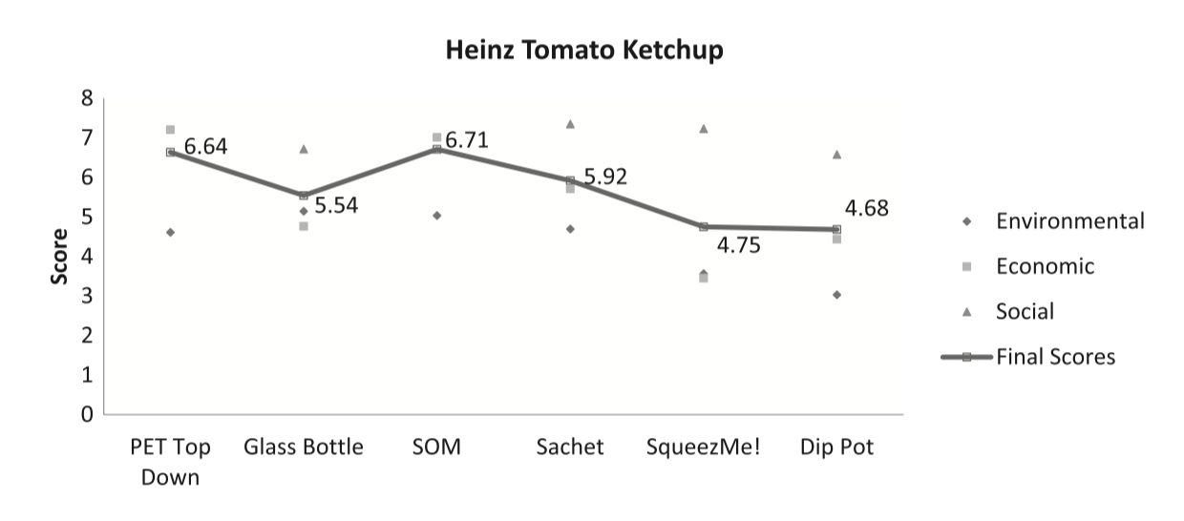

**Figure 9:** Sustainability of different packaging designs for Heinz Tomato Ketchup

Figure 9 above shows the estimated overall sustainability of different packaging types for one product, revealing that between different types of plastic and glass there doesn’t appear to be a huge variation (Rezaei *et al.*, 2019). A good point made by Russell (2014) is that the environmental impacts of packaging are often minor compared to those of what they are transporting (ie. the food); packaging must ensure it delivers the food it contains to the consumer in good condition because if food is spoiled and must be disposed of, the negative environmental impacts will be much greater (with the reasons for this seen in the results of the analysis above). Therefore packaging should be seen as part of the whole food system and scrutinised based on its impact and contribution to this system – does it optimise resource use and reduce waste? Striking a balance between these factors is the key issue, demonstrating that there is more complexity than seeing plastic as a negative and tins or glass as a positive due to their perceived easier recyclability. As all used packaging must be removed from the Antarctic, there may be an argument for heavier types of packaging impacting the fuel burn of the ship and therefore being less environmentally friendly, to give one example, but as this waste takes up such a small amount of the ship’s cargo capacity, one wonders if it is significant enough to be of concern.

Of course, this (any many other issues discussed in this report) are highly complex issues and would benefit from further research, but hopefully the point has been made that, in simplistic terms, there is no clear ‘better’ or ‘worse’ packaging due to the number of factors at play.

It should be recognised that numerous ethical and environmental issues that don’t directly impact climate exist in the food sector which haven’t been investigated in this report due to their complexity and the time available. For example, issues around the eco-labelling of certain foods (such as the Marine Stewardship Council MSC blue mark on fish or the Roundtable on Sustainable Palm Oil RSPO mark on products containing palm oil) have recently emerged, with some questioning the provenance of such schemes. This leads to questions of whether making the ordering of fish products conditional on MSC certification is a policy fit for purpose, for example. Thought should be given to potential environmental/ethical trade-offs that may arise – faced with the option of a low-carbon but ethically ambiguous food product or a higher carbon but ethical product, which should be chosen? Another issue that has the potential to cause a significant threat to humanity is antibiotic resistance. This is already posing a challenge to food producers, but if less meat is consumed then the need for intensive farming methods often associated with this issue is reduced, illustrating another link between food production and broader concerns. Food supply chains contain issues beyond climate impact, and these should be considered in future decision-making processes.

While best efforts have been made to be as accurate as possible in the analysis conducted in this report, results are estimates simply because the best scientific knowledge in the area can only make estimates thanks to the differences in climate impact of production systems for even very similar food products across spatial and temporal settings. An example is mycoprotein, the primary constituent in most Quorn branded products, for which a figure of 4kg CO2e was used in the analysis as this was a best estimate available from the academic literature. However, as mentioned in section 4.1.8, Quorn has partnered with the Carbon Trust to produce their own carbon footprints for their products, most of which lie in the 0.5-1.5kg CO2e range, a significant difference to the figure used. This illustrates some of the issues with conducting this kind of analysis; while confidence in the overall picture painted by the results is high, certain food products are likely to have higher uncertainties attached to their calculations than others and it is important to acknowledge this.

As hinted at in the recommendations in section 5, another area that could benefit from further investigation is the transport of fresh food to the Antarctic stations. Ambiguity surrounding the destination of fresh food shipments loaded onto the SDA in South America and the Falklands makes analysing the records difficult, one reason that a need exists for improved recording of certain types of data (more detail on this topic is provided in section 4.3). This report has focused specifically on Rothera and is likely to give a good indication of the supply chain to other stations, but this is something that could also be investigated further. Furthermore, the Antarctic Infrastructure Modernisation Programme (AIMP) is likely to have an impact on some of the analysis in this report as facilities become more efficient, so repeating some of the analysis and comparing findings on its completion could provide some useful insights.

Finally, there remains scope for the use of technologies, both presently available and under development, to have a positive impact on the efficiency and overall sustainability of systems and processes discussed here. Some of these are already in the pipeline, such as a proposal to dehydrate food waste before incineration, increasing the calorific value and therefore improving the efficiency of incineration. Hydroponics – growing small amounts of food such as salad leaves on-station in a soil-free process – could have potential in the Antarctic context. Halley station’s initial plans included provision for such a facility, but it was later removed on cost-benefit grounds. The dual benefits of having a small supply of fresh food coupled with the mental health and morale-boosting impact of accessing a warm, humid environment with live plants could provide Rothera or other stations with a real asset, as has been seen at many other nation’s Antarctic outposts (Bamsey *et al.*, 2015; Patterson, 2011). Although previously discounted on biosecurity grounds, it may be worth revisiting the viability of a composting facility at Rothera as well, which would remove the need for so many energy-intensive incinerator burns even if the compost produced had to ultimately be shipped out rather than used on-station.

# Conclusions

Before this report was published, the climate impact of the BAS Antarctic food system had not been investigated in depth, leaving questions regarding the significance of the food supply chain to overall emissions and emission reduction targets unanswered. To rectify this knowledge gap, a whole-system approach was utilised to estimate the contribution of each stage of the food life cycle to overall food-related emissions (for which an estimate was also made). Food sent from the UK to Rothera in 2020 was estimated to produce 263919kg CO2e over its lifecycle; referring back to figure 1 at the start of this report, this figure equates to about 1.25% of total organisational emissions, as can be seen in figure 10. This may seem like a relatively small proportion but consider this: this number represents an estimate of the food-related emissions for Rothera alone and once food consumed elsewhere in the organisation (including on the ship and in Cambridge for example) is taken into account, it is entirely conceivable this proportion would increase several percentage points.

**Figure 10:** Rothera food emissions relative to BAS overall carbon footprint 2020

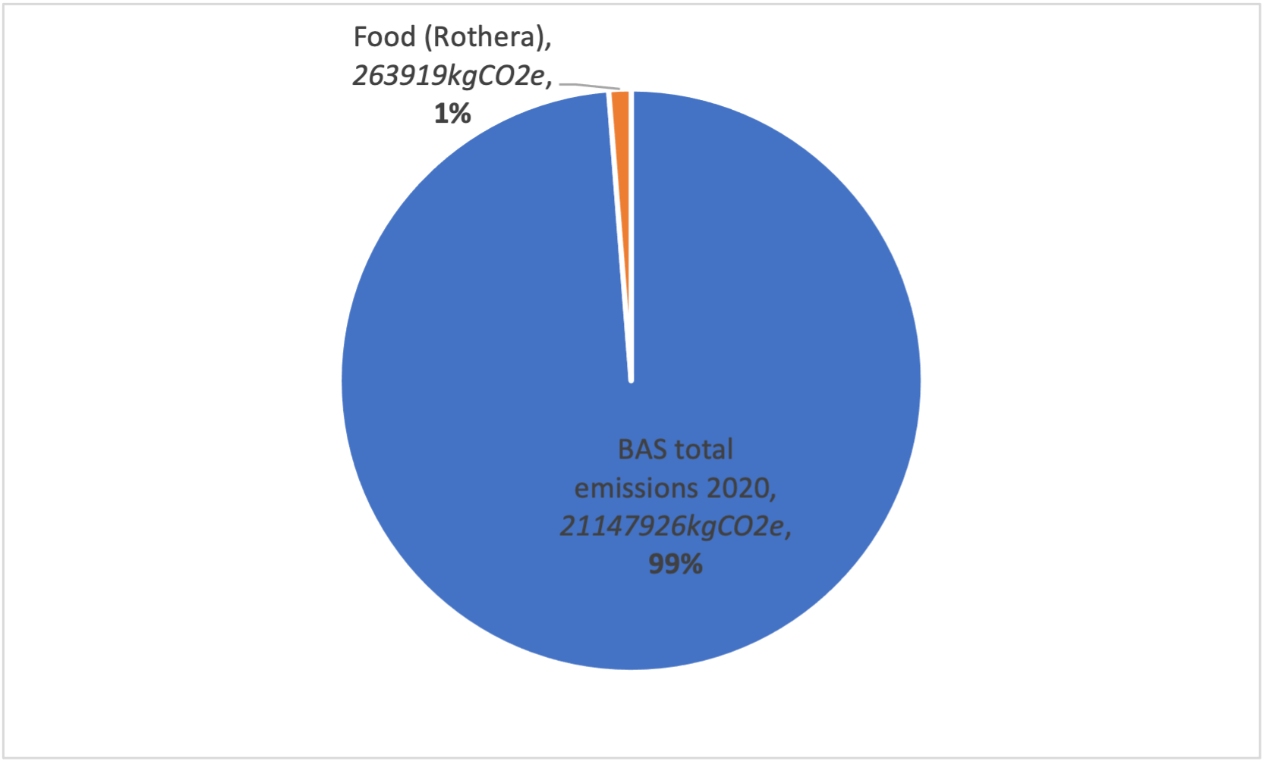

Furthermore, and a key point to note from this report, is that much of BAS’s emissions (as can be seen from figure 1) come from hard-to-decarbonise areas like ships, aircraft and station energy production. Due to the very nature of the organisation and the work it conducts, making significant gains in efficiency and greenhouse gas reductions in these areas would be particularly difficult. Food, on the other hand, is an area where significant carbon reductions can be made easily, relatively quickly and without adverse impact on the operational capabilities of the wider organisation, as the earlier analysis has shown. Indeed, the dual environmental and health benefits of changing diets in the ways recommended could lead to co-benefits like a physically and mentally healthier workforce, in turn increasing the efficiency of work and decreasing the likelihood of environmentally and logistically troublesome medical incidents.

Another key takeaway is that, while a primarily plant-based diet consisting of vegetables, pulses and meat alternatives remains the most carbon-friendly option, doing away with meat, fish and other products like cheese is not the only way to achieve significant carbon reductions in the coming years. Reducing the number of meals where meat is available by just one or two times a week and replacing beef and lamb with chicken and pork can also lead to substantial emissions reductions while continuing to provide options for meat eaters unprepared for a rapid dietary shift.

One potentially surprising result of the analysis was the high contribution of storage-related emissions to the total. This was primarily due to the energy consumption of the static reefers kept at Rothera, which is ultimately provided by diesel generators. However, as no actual data was available on reefer energy consumption some assumptions had to be made in the calculations; the impact on energy use of trying to keep food frozen when the ambient outside temperature is below freezing is unknown, as described in section 6. The actual energy consumption is planned to be measured over the coming 2021/2 season, after which a better estimate could be made.

The recommendations set out in section 5 lay the foundations for a clear pathway to improving the Antarctic food system, not just in terms of climate impact but considering issues such as resource efficiency and health as well. Those with experience of living in the Antarctic may find some of these surprising, while some will be less so. By identifying the key areas where improvements can be made, this report seeks to take the first step towards ensuring a food system that works for everyone while also making a positive contribution to BAS’s net zero target towards 2040 and beyond.

# Reference list

Alcock, T., Salt, D., and Ramsden, S. (2020) A harmonised systems-wide re-analysis of greenhouse gas emissions from sunflower oil production. : 1–27. doi:10.1101/2020.06.19.161893.

Amienyo, D., Gujba, H., Stichnothe, H., and Azapagic, A. (2013) Life cycle environmental impacts of carbonated soft drinks. *International Journal of Life Cycle Assessment* 18(1): 77–92.

Bamsey, M. T., Zabel, P., Zeidler, C., Gyimesi, D., Schubert, D., Kohlberg, E., Mengedoht, D., Rae, J., and Graham, T. (2015) Review of Antarctic Greenhouses and Plant Production Facilities : A Historical Account of Food Plants on the Ice. In *45th International Conference on Environmental Systems*.

BAS (2021) BAS Carbon Footprint 2020/21.

Bouwman, A. F., Van Vuuren, D. P., Derwent, R. G., and Posch, M. (2002) A global analysis of acidification and eutrophication of terrestrial ecosystems. *Water, Air, and Soil Pollution* 141(1–4): 349–382.

Canellada, F., Laca, A., Laca, A., and Díaz, M. (2018) Environmental impact of cheese production: A case study of a small-scale factory in southern Europe and global overview of carbon footprint. *Science of the Total Environment* 635: 167–177.

Cerutti, A. K., Beccaro, G. L., Bruun, S., Bosco, S., Donno, D., Notarnicola, B., and Bounous, G. (2014) Life cycle assessment application in the fruit sector: State of the art and recommendations for environmental declarations of fruit products. *Journal of Cleaner Production* 73: 125–135.

Clune, S., Crossin, E., and Verghese, K. (2017) Systematic review of greenhouse gas emissions for different fresh food categories. *Journal of Cleaner Production* 140: 766–783.

Del Borghi, A., Gallo, M., Strazza, C., and Del Borghi, M. (2014) An evaluation of environmental sustainability in the food industry through Life Cycle Assessment: The case study of tomato products supply chain. *Journal of Cleaner Production* 78: 121–130.

Dimbleby, H. (2021) *National Food Strategy: The Plan*.

Edwards-Jones, G., Plassmann, K., and Harris, I. M. (2009) Carbon footprinting of lamb and beef production systems: Insights from an empirical analysis of farms in Wales, UK. *Journal of Agricultural Science* 147(6): 707–719.

Espinoza-Orias, N., Stichnothe, H., and Azapagic, A. (2011) The carbon footprint of bread. *International Journal of Life Cycle Assessment* 16(4): 351–365.

Finnegan, W. (2017) A review of environmental life cycle assessment studies examining cheese production. *Jilca* : 1773–1787.

Fitzgerald, W. B., Howitt, O. J. A., Smith, I. J., and Hume, A. (2011) Energy use of integral refrigerated containers in maritime transportation. *Energy Policy* 39(4): 1885–1896.

Frankowska, A., Rivera, X. S., Bridle, S., Kluczkovski, A. M. R. G., Tereza da Silva, J., Martins, C. A., Rauber, F., Levy, R. B., Cook, J., and Reynolds, C. (2020) Impacts of home cooking methods and appliances on the GHG emissions of food. *Nature Food* 1(12): 787–791.

Gosalvitr, P., Cuéllar-Franca, R. M., Smith, R., and Azapagic, A. (2021) Integrating process modelling and sustainability assessment to improve the environmental and economic sustainability in the cheese industry. *Sustainable Production and Consumption* 28(2021): 969–986.

Guillard, V., Gaucel, S., Fornaciari, C., Angellier-Coussy, H., Buche, P., and Gontard, N. (2018) The Next Generation of Sustainable Food Packaging to Preserve Our Environment in a Circular Economy Context. *Frontiers in Nutrition* 5(December): 1–13.

Leinonen, I., Williams, A. G., Wiseman, J., Guy, J., and Kyriazakis, I. (2012) Predicting the environmental impacts of chicken systems in the united kingdom through a life cycle assessment: Egg production systems. *Poultry Science* 91(1): 26–40.

Lesschen, J. P., van den Berg, M., Westhoek, H. J., Witzke, H. P., and Oenema, O. (2011) Greenhouse gas emission profiles of European livestock sectors. *Animal Feed Science and Technology* 166–167: 16–28.

March, M. D., Hargreaves, P. R., Sykes, A. J., and Rees, R. M. (2021) Effect of Nutritional Variation and LCA Methodology on the Carbon Footprint of Milk Production From Holstein Friesian Dairy Cows. *Frontiers in Sustainable Food Systems* 5(April): 1–16.

Mouron, P., Willersinn, C., Möbius, S., and Lansche, J. (2016) Environmental profile of the swiss supply chain for French fries: Effects of food loss reduction, loss treatments and process modifications. *Sustainability (Switzerland)* 8(12).

Notarnicola, B., Sala, S., Anton, A., McLaren, S. J., Saouter, E., and Sonesson, U. (2017) The role of life cycle assessment in supporting sustainable agri-food systems: A review of the challenges. *Journal of Cleaner Production* 140: 399–409.

Parker, R. W. R., Blanchard, J. L., Gardner, C., Green, B. S., Hartmann, K., Tyedmers, P. H., and Watson, R. A. (2018) Fuel use and greenhouse gas emissions of world fisheries. *Nature Climate Change* 8(4): 333–337.

Patterson, R. L. (2011) *Description, operation and production of the south pole food growth chamber*. University of Arizona doi:10.17660/ActaHortic.2012.952.75.

Ponsioen, T., and Blonk, H. (2011) *Case studies for more insight into the methodology and composition of carbon footprints of table potatoes and chips*.

Poore, J., and Nemecek, T. (2018) Reducing food’s environmental impacts through producers and consumers. *Science* 360(6392): 987–992.

Rezaei, J., Papakonstantinou, A., Tavasszy, L., Pesch, U., and Kana, A. (2019) Sustainable product-package design in a food supply chain: A multi-criteria life cycle approach. *Packaging Technology and Science* 32(2): 85–101.

Roy, P., Nei, D., Orikasa, T., Xu, Q., Okadome, H., Nakamura, N., and Shiina, T. (2009) A review of life cycle assessment (LCA) on some food products. *Journal of Food Engineering* 90(1): 1–10.

Rugani, B., Vázquez-Rowe, I., Benedetto, G., and Benetto, E. (2013) A comprehensive review of carbon footprint analysis as an extended environmental indicator in the wine sector. *Journal of Cleaner Production* 54: 61–77.

Russell, D. A. M. (2014) Sustainable (food) packaging - an overview. *Food Additives and Contaminants - Part A Chemistry, Analysis, Control, Exposure and Risk Assessment* 31(3): 396–401.

Smetana, S., Mathys, A., Knoch, A., and Heinz, V. (2015) Meat alternatives: life cycle assessment of most known meat substitutes. *International Journal of Life Cycle Assessment* 20(9): 1254–1267.

Souza Filho, P. F., Andersson, D., Ferreira, J. A., and Taherzadeh, M. J. (2019) Mycoprotein: environmental impact and health aspects. *World Journal of Microbiology and Biotechnology* 35(10): 1–8.

Tesco (2012) *Product Carbon Footprint Summary*.

The Carbon Trust (2021) *Quorn Footprint Comparison Report*.

UN (/2021) United Nations Food Systems Summit. Accessed: 1st October 2021 <https://www.un.org/en/food-systems-summit/summit. >.